TIMECLOCK PLUS INSTRUCTIONS

CONFIGURING YOUR TIMECLOCK PLUS APP:

- Download TimeClock Plus Version 7

- Choose Next

- Go to “desired scheme”. Choose https
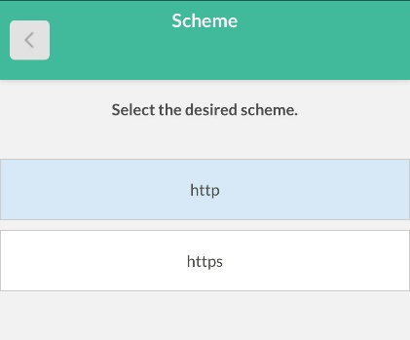

- Host: 301082.tcplusondemand.com and Port is 443 then Next
- It takes you to “This app requires a connection to external server” then Next
- It will then go back to the beginning and ask you to choose “desired scheme” again and you should choose https. The information in Host and Port will be pre-populated then choose Next.

- Namespace: 301082
- Select the company you want to log hours for. Choose: “Albuquerque Public Schools”
- Enter your ID number (Same as Smart Find ID)
Enter PIN (it is your Access ID)

